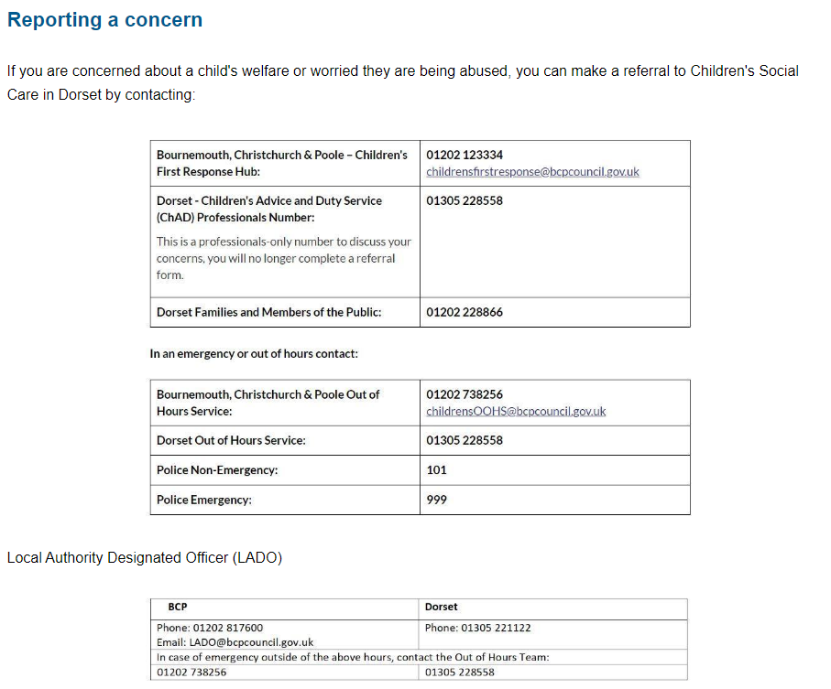

Useful Contact Numbers
Name | Contact number
BCP Domestic Abuse Support | 01202 710777 or 0800 0325204
24hr National DV Helpline ( Refuge) | 08082000247
Domestic Violence Support Services | 01202 547755
Dorset Police Safe school and Communities team | 01202 222844
DFE’s Counter Extremist Helpline (Prevent) | 020 7340 7264
Anti Terrorist Hotline | 0800 789 321
Child line | 0800 111
NSPCC Whistleblowing helpline | 0800 0280285

